Title: Along the lines of “Exploring Halocline Tidal Variability in Colvos Passage Puget Sound with a DIY float”

Caleb Flaim1

[1cflaim@uw.edu](mailto:1cflaim@uw.edu) University of Washington, School of Oceanography

23 October 2023

1. Project summary
   1. This project aims to quantify haloclines in Colvos Passage Puget Sound, WA, and their relationship to tidal cycles by back-calculating salinity from measured and known variables collected by a DIY buoyancy-driven AUV. Calculated salinity values will be directly compared to those measured by seagliders with freshly calibrated ct-sails for validation.
   2. Traditional AUV data collection methods cost on the order of $100,000; this project aims to build the float in under $500 and deploy on ships of opportunity to reduce the cost of data collection.
2. Introduction
   1. Currents in Colvos Passage always flow northward, regardless of the tidal direction. Currents reach a maximum during the ebb tide and a minimum (near zero) during the flood tide (Oval 2019; LiveOcean). Puget Sound density structures are predominated by salinity and determined by the stratification of freshwater on top of dense seawater.
   2. 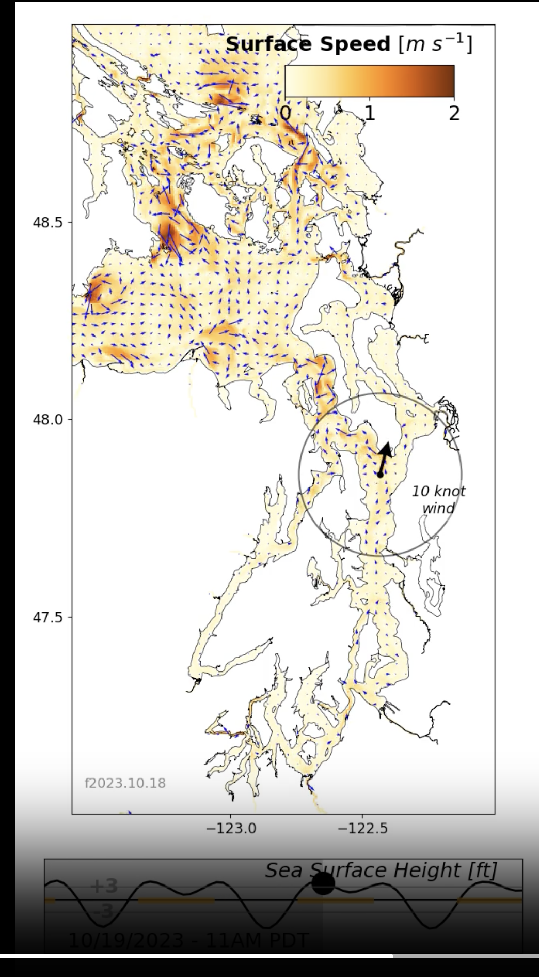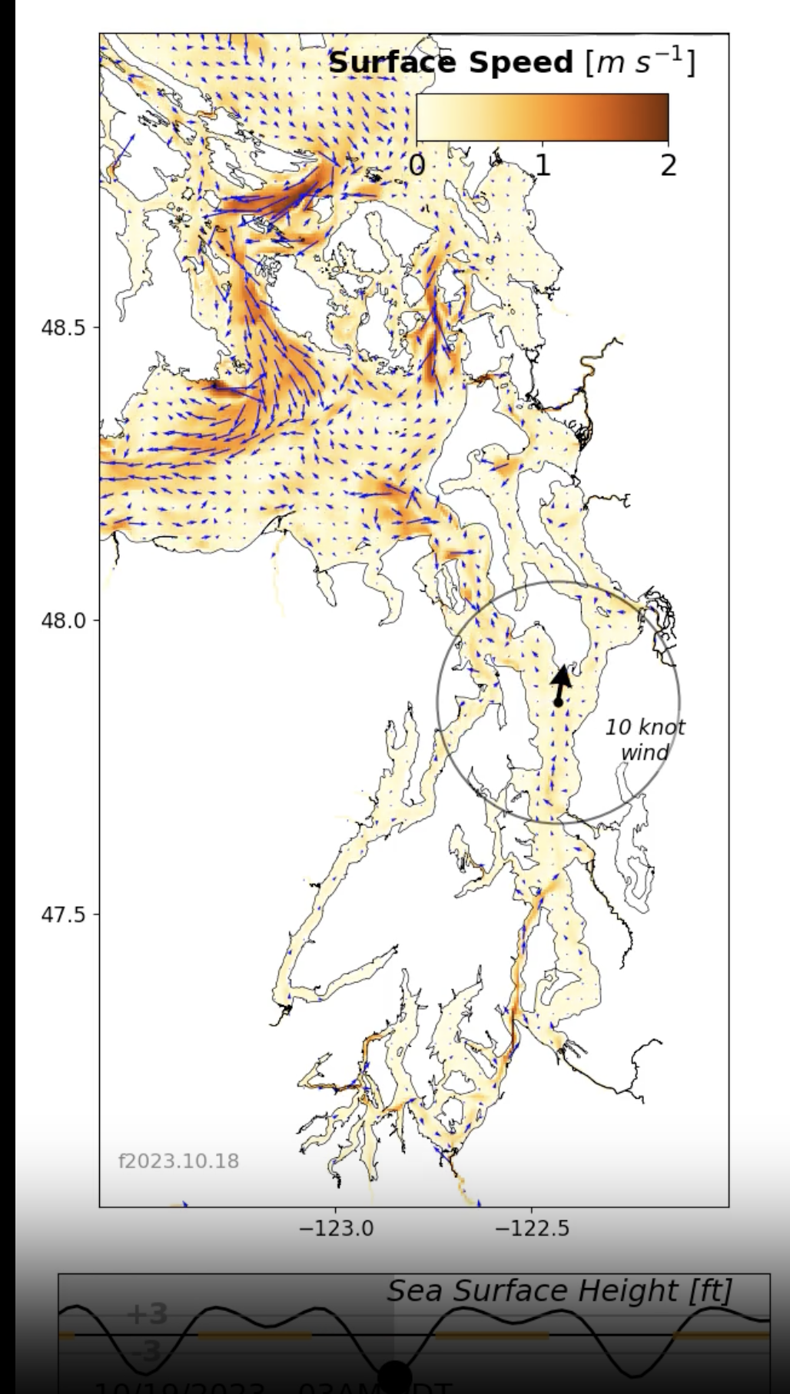
   3. Obtaining high-resolution data from locations like this requires research cruises aboard ships like the RV Carson or the use and acquisition of expensive AUVs such as seagliders or Argo floats. Research vessels with CTD sampling capabilities cost ~$10,000+ per day and AUVs of the class cost $100,000 - $250,000 to purchase and set up
   4. A DIY float that costs less than $1,000 to build can greatly increase the quantity of data obtainable on short timescales in locations such as this.
3. Proposed work
   1. **Hypothesis:** Halocline strength changes during a 12-hr tidal cycle in Colvos Passage, WA, as measured by a DIY buoyancy-driven float.
   2. **Null:** There is no change in halocline strength during a 12-hr tidal cycle.
   3. Similar to Dr. Trevor Harrison’s microfloats (Harrison, 2021; Harrison et al., 2023), we will build a small, buoyancy-driven float. The float’s sensing, data telemetry, and buoyancy will be controlled by an ESP32 Feather Huzzah V2 microcontroller. This controller has 12-bit analog read pins (the same as seagliders) that will be used for analog pressure and temperature sensors
   4. Digital lux and temperature sensors will collect supplemental data.
   5. Data regarding water density will be measured using the float's known mass and volume range as the buoyancy changes. The absolute positioning IMU will be used to track when the float has reached a point of neutral buoyancy.
   6. With the measured density, pressure, and temperature data, an estimate of salinity should be able to be achieved. This data will be used to approximate a salinity transect through Colvos Passage.
4. Financial budget
   1. Float components
      1. Electrical
         1. General
            1. 3 - 5x perfboard ~ $0.50 each*
            2. Misc wires ~ $15 total*
            3. Male header pins ~ $5 total*
            4. Female header pins ~ $5 total*
            5. Solder ~ $5 - $10 total*
            6. Resistors ~ $1 total
            7. Misc GPS and radio wires ~ $15 total
         2. Control (* indicates materials that we have)
            1. 2x ESP32 Feather Huzzah V2 ~ $15 each*
            2. 1x BLDC stepper motor ~ $15 - $30 each
            3. 1x 5v, 5A voltage step-down regulator ~ $30*
            4. 1x custom battery pack ~ $15
         3. Sensing
            1. 1x Analog pressure sensor ~ $20*
            2. 1x Thermistor ~ $2*
            3. 1x adafruit data logger feather wing ~ $10*
            4. 3x digital temperature sensor ~ $10 each*
            5. 1x Internal BMP180 pressure sensor ~ $10*
            6. 1x Internal DHT22 humidity sensor ~ $5*
            7. 1x TSL2591 lux sensor ~ $10*
            8. 1x Adafruit 9-DOF Absolute Orientation IMU Fusion Breakout - BNO055 ~ $35*
            9. 1x Adadfruit ultimate GPS ~ $30*
            10. 2x 915 Mhz LoRa radio module ~ $20 each*
            11. 1x GPS antenna ~ $20*
            12. 2x LoRa antenna ~ $5 each*
            13. 1x precision current meter ~ $10*
      2. Mechanical
         1. 1x Low pitch, high thread count lead screw ~ $15
         2. Misc O-rings ~ $10 total*
         3. Misc PVC pipe for piston ~ $15
      3. Pressure casing
         1. 1x 4” PVC pipe ~ $10
         2. 2x 4” PVC endcaps ~ $10 each
         3. 1x Pressure port ~ $10*
         4. 4-10 cable glands ~ $10 each*
         5. Epoxy ~ $20 total*
      4. Preliminary wiring diagram
         1. 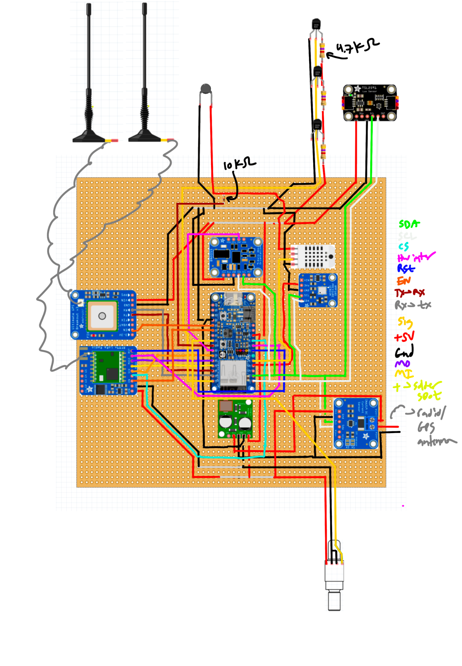
      5. Current electrical board status
         1. 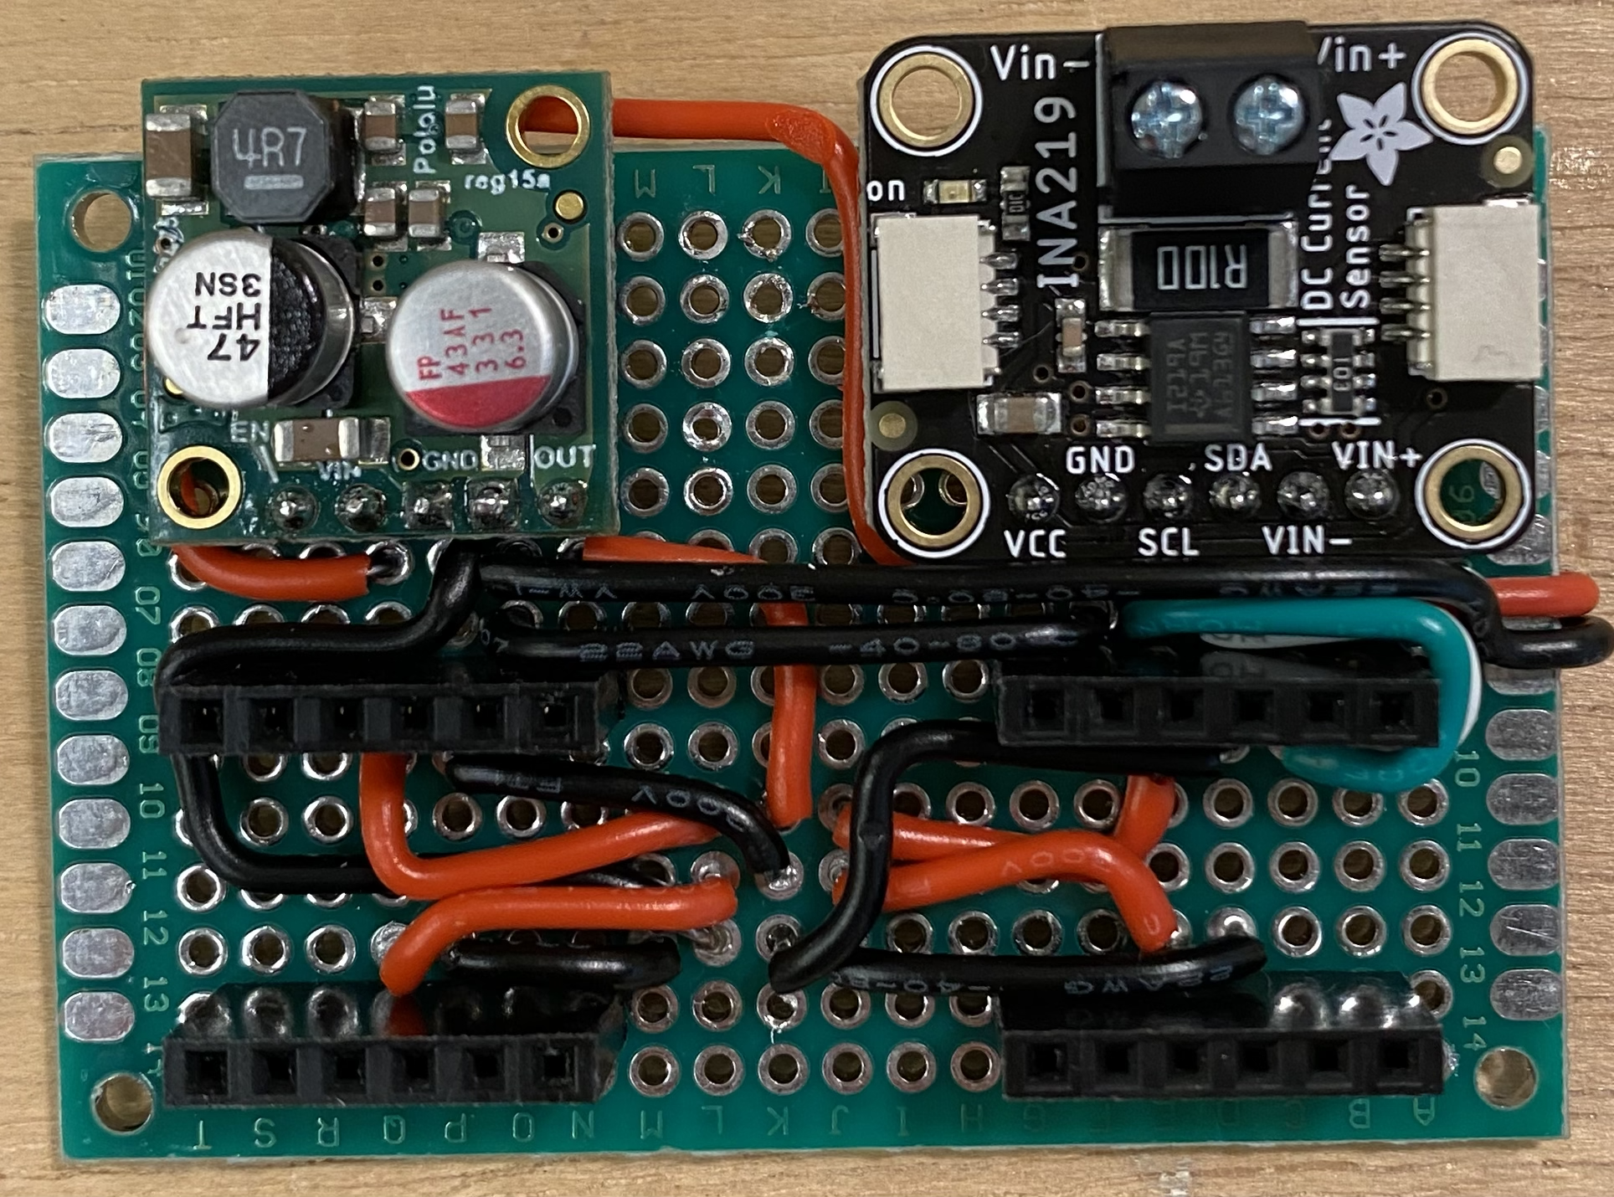
         2. 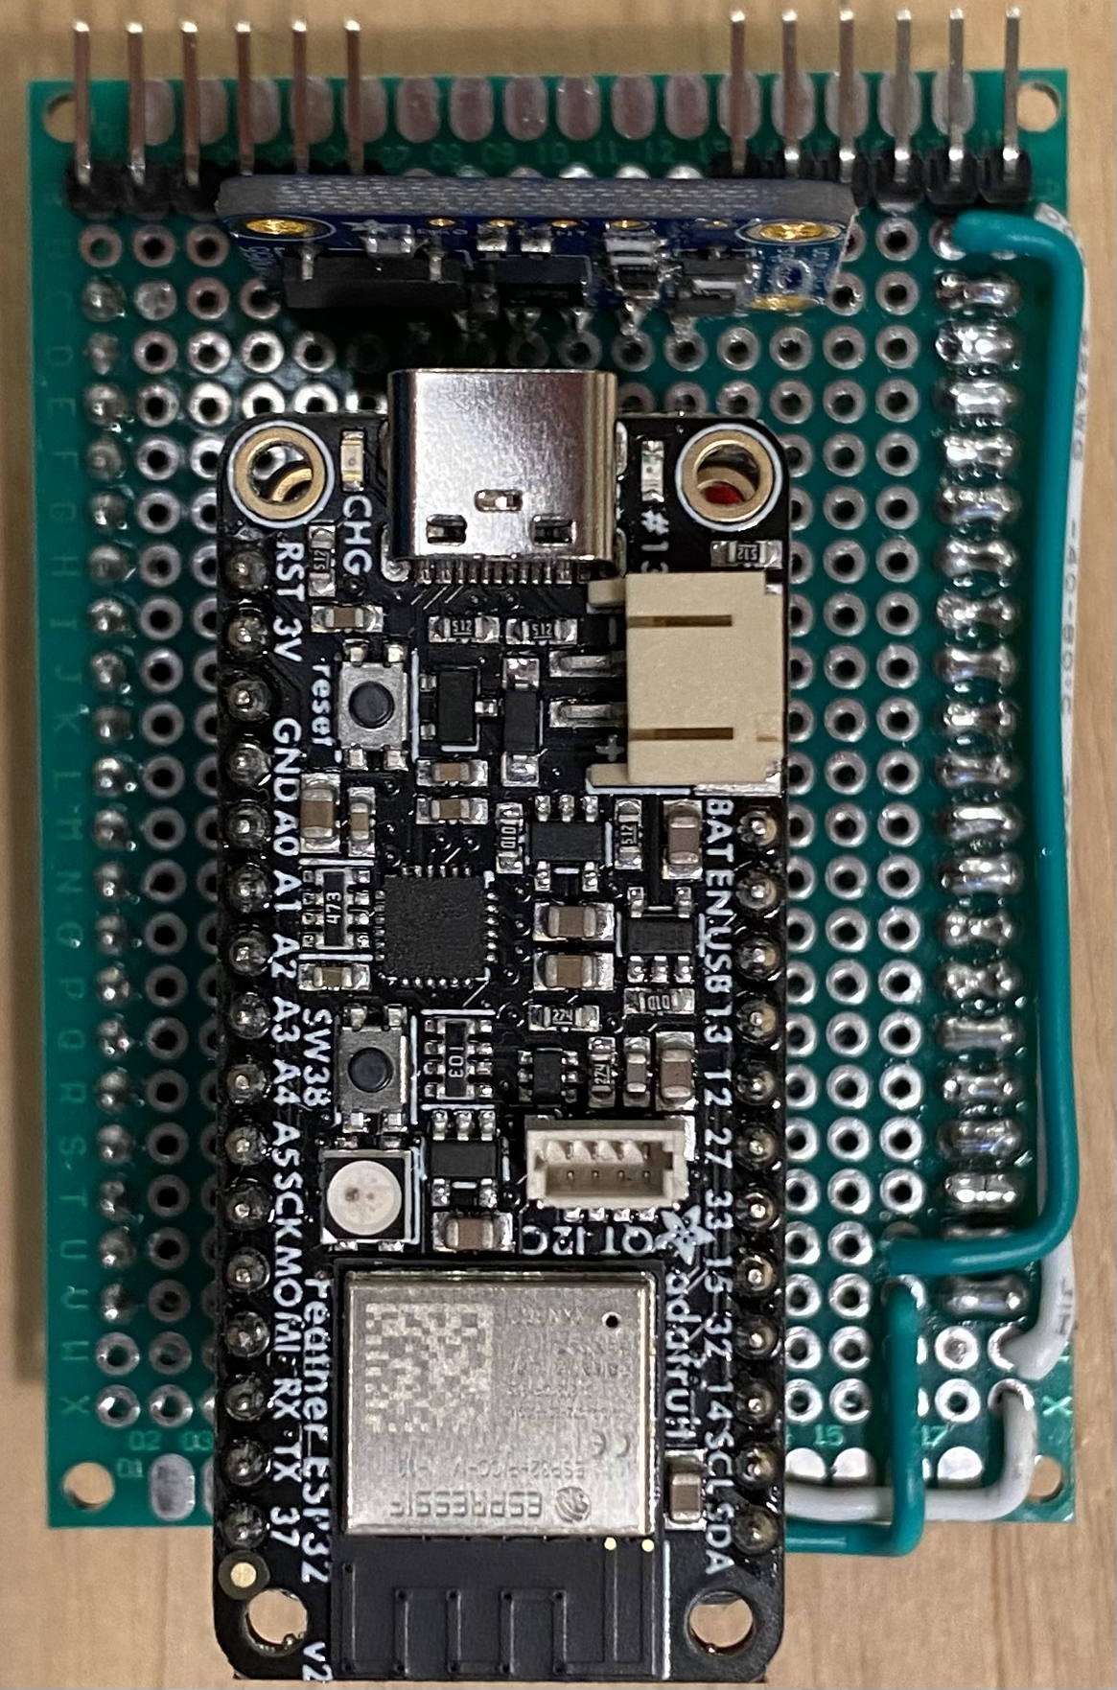
         3. 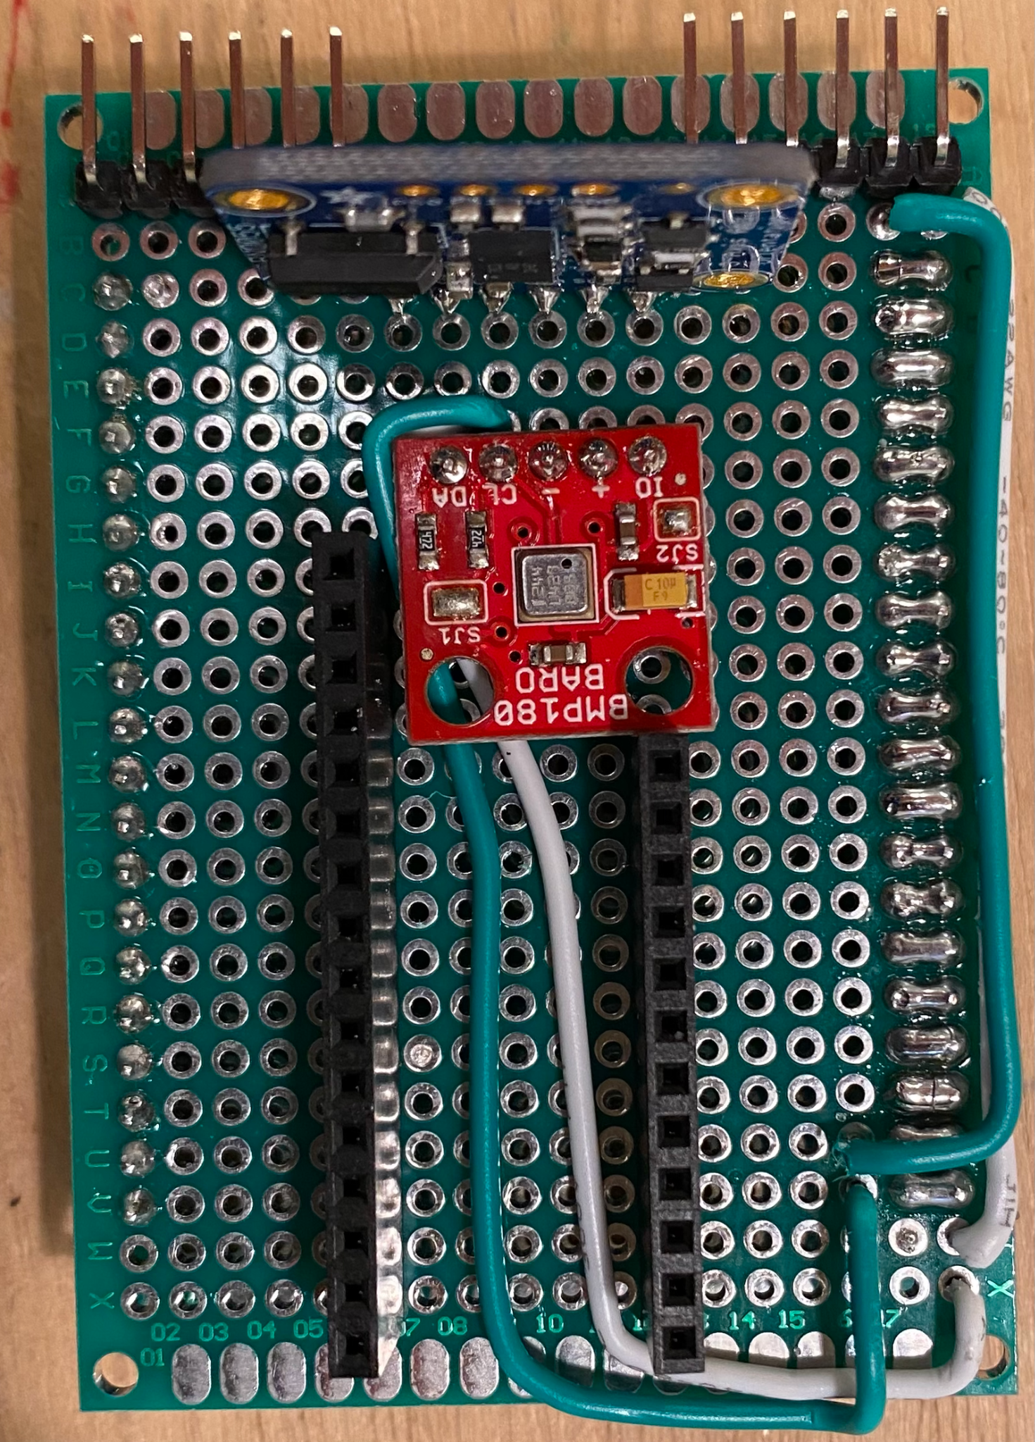
         4. 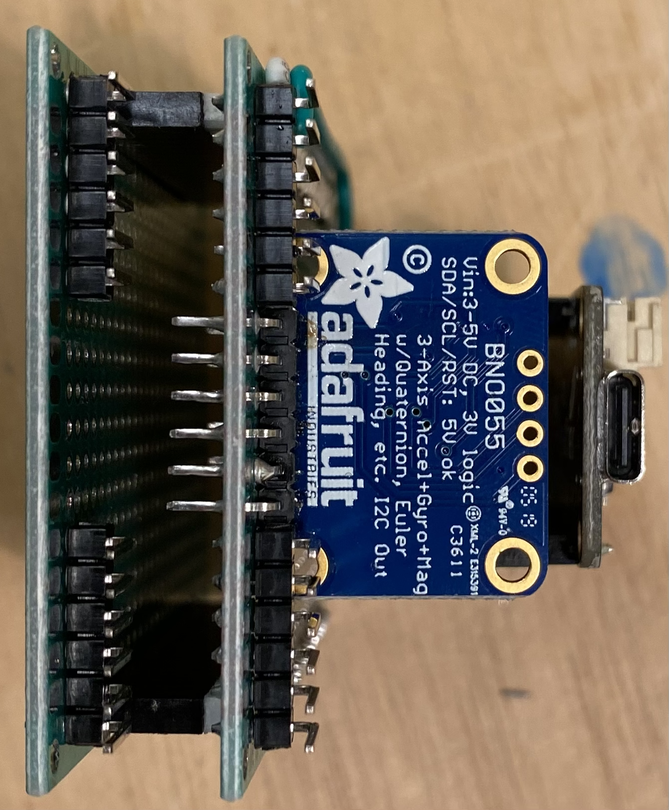
5. Project Timeline
   1. **October 23 - 29:** Finish assembling and programming electronics for the surface drifter experiment.
   2. **October 30 - November 5:** Test surface drifter in OSB test tank and calibrate thermistor and pressure sensor. Begin constructing float VBD system.
   3. **November 6 - 9:** Overnight testing of data collection and telemetry in test tank. VBD system construction.
   4. **November 10:** Surface drifter deployment near Shillshole alongside SG175.
   5. **November 11 - 19:** Work on turning the surface drifter into a profiling float.
   6. **November 20 - December 1:** Float VBD testing and calibration in test tank.
   7. **December 2 - 7:** Overnight testing of float VBD system and data telemetry in test tank.
   8. **December 8:** Deployment alongside SG195 (and maybe SG175) in Colvos passage.
6. References (not all used in the outline, but have been read for contextualization)

Bretschneider, D. E., Cannon, G. A., Holbrook, J. R., & Pashinski, D. J. (1985). Variability of subtidal current structure in a fjord estuary: Puget Sound, Washington. Journal of Geophysical Research: Oceans, 90(C6), 11949–11958. <https://doi.org/10.1029/JC090iC06p11949>

Eriksen, C. C., Osse, T. J., Light, R. D., Wen, T., Lehman, T. W., Sabin, P. L., Ballard, J. W., & Chiodi, A. M. (2001). Seaglider: a long-range autonomous underwater vehicle for oceanographic research. IEEE Journal of Oceanic Engineering, 26(4), 424–436. <https://doi.org/10.1109/48.972073>

Frajka-Williams, E., Eriksen, C. C., Rhines, P. B., & Harcourt, R. R. (2011). Determining Vertical Water Velocities from Seaglider. Journal of Atmospheric and Oceanic Technology, 28(12), 1641–1656. <https://doi.org/10.1175/2011JTECHO830.1>

Harrison, T. W., Clemett, N., Polagye, B., & Thomson, J. (2023). Experimental Validation of Float Array Tidal Current Measurements in Agate Pass, Washington. Journal of Atmospheric and Oceanic Technology, 40(4), 475–489. <https://doi.org/10.1175/JTECH-D-22-0034.1>

Harrison, T. W., & Polagye, B. (2021). Buoyancy controlled float swarms for distributed sensing in coastal waterways. [University of Washington Libraries].

Live ocean: <https://faculty.washington.edu/pmacc/LO/LiveOcean.html>

Ovall, B. (2019). Density structure in the outflow region of Colvos Passage: Observational analysis and model comparison.

Seim, H. E., & Gregg, M. C. (1997). The importance of aspiration and channel curvature in producing strong vertical mixing over a sill. Journal of Geophysical Research, Washington, DC, 102(C2), 3451–3472. <https://doi.org/10.1029/96JC03415>